

Travlr Getaways

CS 465 Project Software Design Document
Version 3.0

Table of Contents

Travlr Getaways 1
CS 465 Project Software Design Document 1
Table of Contents 2
Document Revision History 2
Executive Summary 3
Design Constraints 3
System Architecture View 4
Component Diagram 4
Sequence Diagram 5
Class Diagram 6
API Endpoints 7
The User Interface 8

Document Revision History

Version | Date | Author | Comments
3.0 | 6/21/2026 | Nicholas Deniz | Updating the API’s and completing User Interface. Also, making a few edits in Executive Summary and Design Constraints
2.0 | 6/6/2026 | Nicholas Deniz | Will be completing the Sequence Diagram, the Class Diagram, and the API Endpoints
1.0 | 5/23/2026 | Nicholas Deniz | Will be completing the Executive Summary, Design Constraints, and the System Architecture View: Component Diagram sections

Executive Summary

Travlr Getaways is a full stack web application that is meant to give the user information about traveling. This application will use the MEAN stack, which includes MongoDB, Express, Angular, and Node.js. MongoDB is a database and will store the applications data, like the trips, prices, and images. Express oversees the routes and API requests, like if someone were to go to /travel. Angular will build the admin single page, which allows the admin to add, edit, see, and update the trips. Node.js lets us run JavaScript on the server, allowing the backend code to run.
The application will have a customer-facing website that lets users view travel options and details. It will also have an administrator single-page application, or SPA for short, that lets authorized users manage trip information. SPA uses Angular to have an interactive user experience without the page reloading each time. This architecture allows the user experience to be separated from admin tools while still letting the application work with the same server and database.

Design Constraints

The Travlr Getaways application has a couple of design constraints that need to be followed. One design constraint is the usage of the MEAN stack, while it is helpful it can be limiting. For the MEAN stack to work the design needs to have the client side, server side, and the database fully separated for the stack to work properly. Another constraint is that must have both a customer-facing website and an admin SPA. The customer-facing side should be straightforward and simple while the admin side must provide the functionality for managing trip information. The application must also need to be designed so that data can be stored, retrieved, deleted, and updates through the server and database instead of static pages. Making sure that the system is organized and has reusable components. Another design constraint is that Node.js runs on a single-threaded event loop which means asynchronized code must be used to not cause a blockage. Another design constraint is the architecture keeping the API completely stateless. Another design constraint is security; admin rights should not be available to customer users. Authentication is needed to protect the admin functions like adding or deleting trip info. These constraints keep the architecture organized and allow for future expansion while keeping it secure and stable.

System Architecture View

Component Diagram

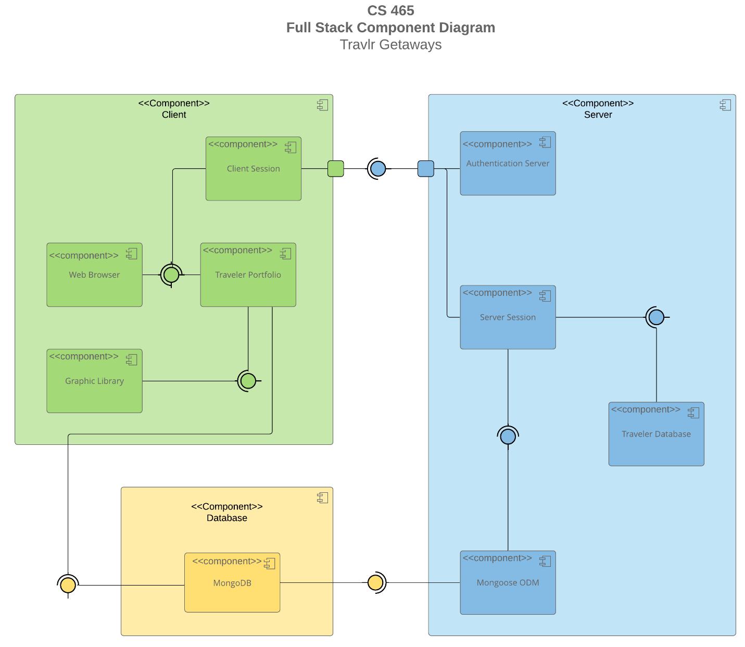

This component diagram shows the Travlr Getaways application separated into three sections, the client side, the server side, and the database. The client side is the front-end section that shows what the user will interact with in the application. It includes the web browser, client session, traveler portfolio, and graphic library. These components work in combination to show travel info and guide the user’s interaction will the application.
The server side is the backend section that has the applications logic and communications between the client and database. It includes the authentication server, server session, traveler database, and the Mongoose ODM. The auth server oversees the user sign in and who gets access. The server session manages communication between the client and the server. Mongoose ODM is the bridge between JavaScript and MongoDB, which allows the database to be turned into JavaScript objects.
The database component has MongoDB which is where the travel data is stored and used by the application. Overall, the client will sense requests to the server, the server will process them, and the database provides the requested data.

Sequence Diagram

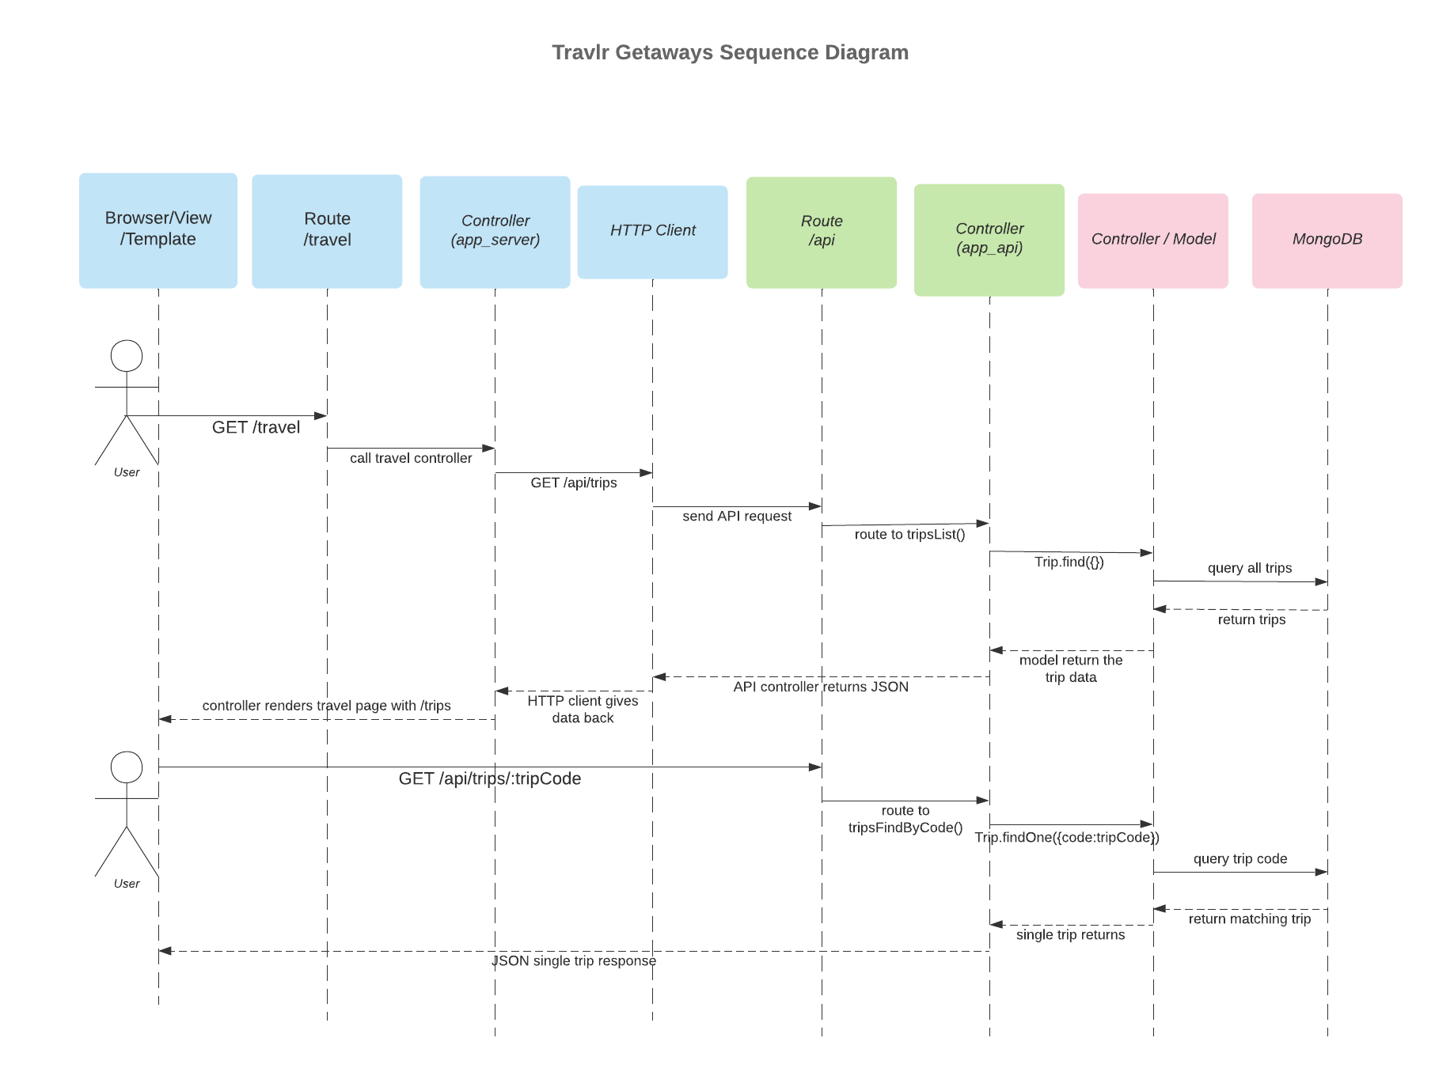

The sequence diagram is showing the flow of logic to retrieve trip information in the Travlr Getaways web application. It starts when the user requests the travel page from the browser. The browser sends a GET request to /travel route which then sends the request to the controller in app_server. The controller doesn’t directly interact with MongoDB but instead uses a HTTP client. Which sends a GET request to the REST API endpoint /api/trips. The API route gets the request and sends it to the API controller in app_api. The API controller calls the trip model which uses Mongoose to query MongoDB for trip records. MongoDB returns the trip data to the model who then returns it to the API controller. The API controller sends the data back as JSON. The HTTP client gives the JSON back to the app_server controller. Lastly, the controller renders the travel page with the trip info displayed to the user.
The second flow shows how the application retrieves a single trip by trip code. A GET request is sent to /api/trips/:tripcode, where :tripcode is the specific code for one trip. The API route sends the request to the tripsFindByCode() controller. The controller uses the trip model to search through MongoDB for that matching tripCode. MongoDB returns what matched and the API sends the single trip back as JSON.

Class Diagram

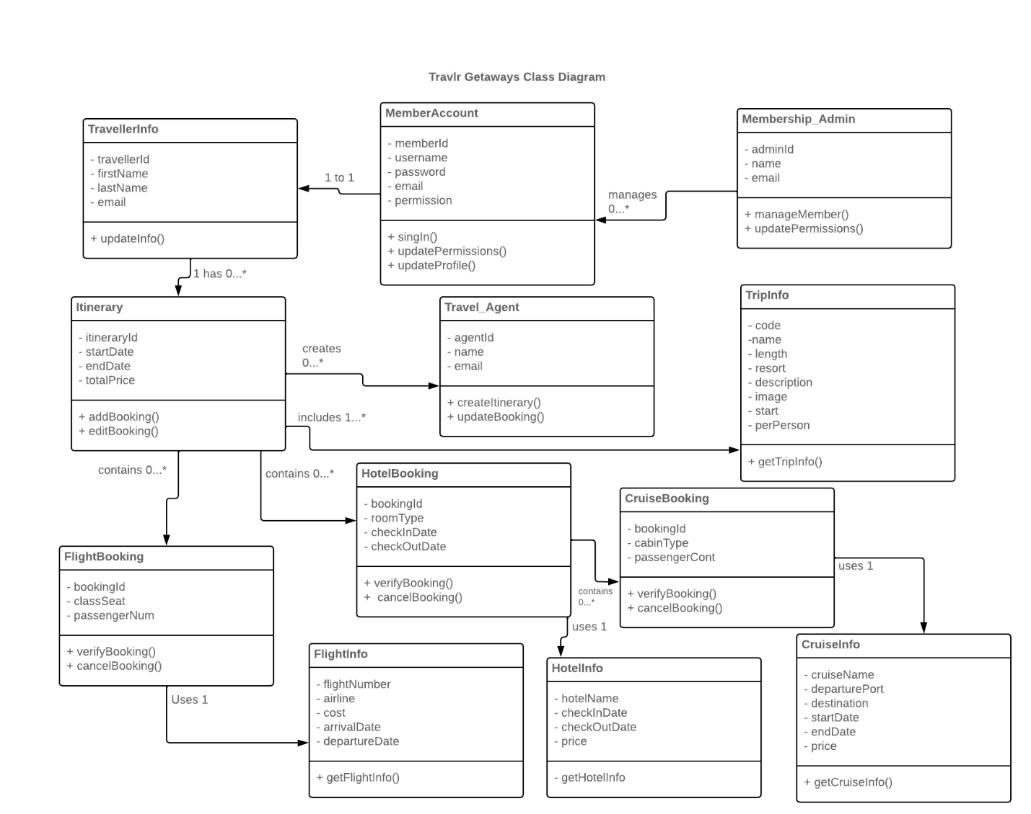
The class diagram shows the main JavaScript classes used by Travlr Getaways web application. Membership_Admin class shows an admins id, name, and email with them managing members and updating permissions. The MemberAccount class signifies the user account and stores info like member id, username, password, email, and permission level. The account is connected to TravelerInfo which has traveler details like traveler id, first and last name, and email. A traveler can have zero or more itineraries.
The Itinerary class shows the travel schedule. Storing info like itinerary id, start date, end date, and total price. An itinerary can include one or more trips through the TripInfo class. The TripInfo class shows the trip data stores in MongoDB like the trip code, name, length, start date, resort, price per person, image, and description.
The diagram shows booking related classes. The itinerary contains flight, hotel, and cruise bookings. Each booking class is connected to an info class. For example, FlightBooking uses FlightInfo, HotelBooking uses HotelInfo, and CruiseBooking uses CruiseInfo. Overall, the diagram shows how accounts info, traveler info, itineraries, trips, bookings, and administrative roles connect to each other in the Travlr Getaways application.

API Endpoints

API interface exposes trip data through RESTful endpoints. The GET /api/trips endpoint returns the full list of trips. The other GET /api/trips/:tripcode endpoints returns a specific trip based on the trip code within the URL. The endpoints separate the front end from the database. The browser doesn’t directly interact with MongoDB. Instead, the request goes through the Express API route, to the controller, then through the Mongoose model, and then to MongoDB. MongoDB returns the data and the API sends it back as JSON. This design makes the applications simpler to maintain. This is because the trip data is stored in the database and entered through a stable API interface instead of it being hardcoded into static pages. POSt /api/trips endpoint adds a new trip to the database. PUT /api/trips/:tripcode endpoint updates/edits a trip that already exists. The POST and PUT routes are protected with the JSON web token auth so only admins that are logged in can add or edit trips.

Method | Purpose | URL | Notes
GET | Retrieves full list of trips | /api/trips | Returns all trip records from the MongoDB trips collection. The endpoint is used when the travel page needs to display all the trips.
GET | Retrieves one trip by the trip code | /api/trips/:tripCode | Returns one trip record that matches the trip code passed within the url. The endpoint is used to test or display a single trip.
POST | Adds new trip | /api/trips | Adds a new trip to MongoDB. The endpoint is protected by JWT auth so only registered users can access it.
PUT | Updates an existing trip | /api/trips/:tripcode | Updates an existing trip in MongoDB. The endpoint is protected by JWT auth so only registered users can access it.
POST | Registers a user | /api/register | Creates a user account and returns a JWT token.
POST | Logs a user in | /api/login | Authenticates a user and returns a JWT token that is stored by Angular SPA.

The User Interface

Unique trip is Maple Hut:

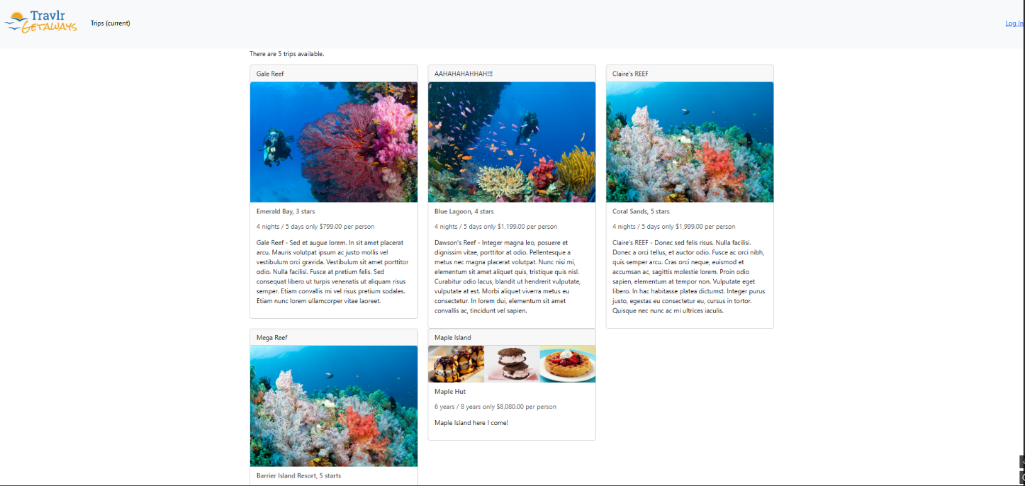

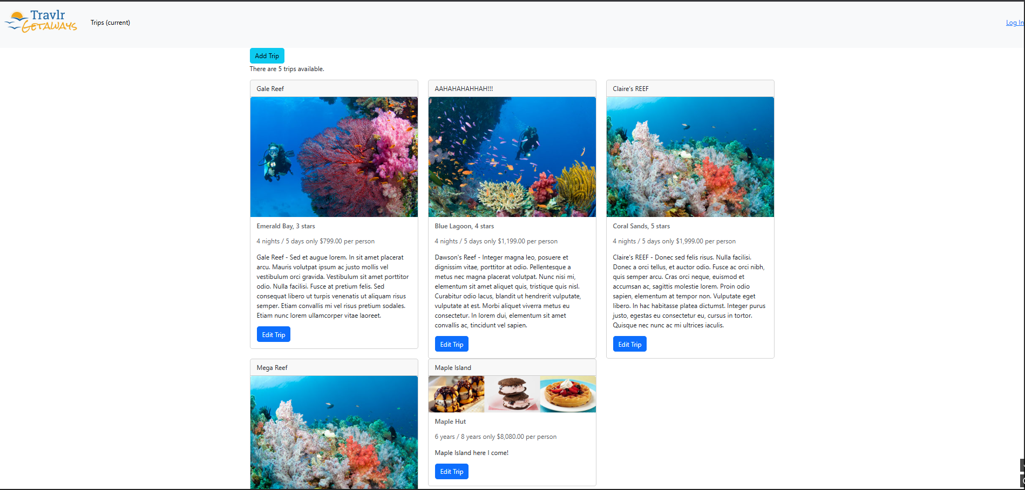

The Edit screen:

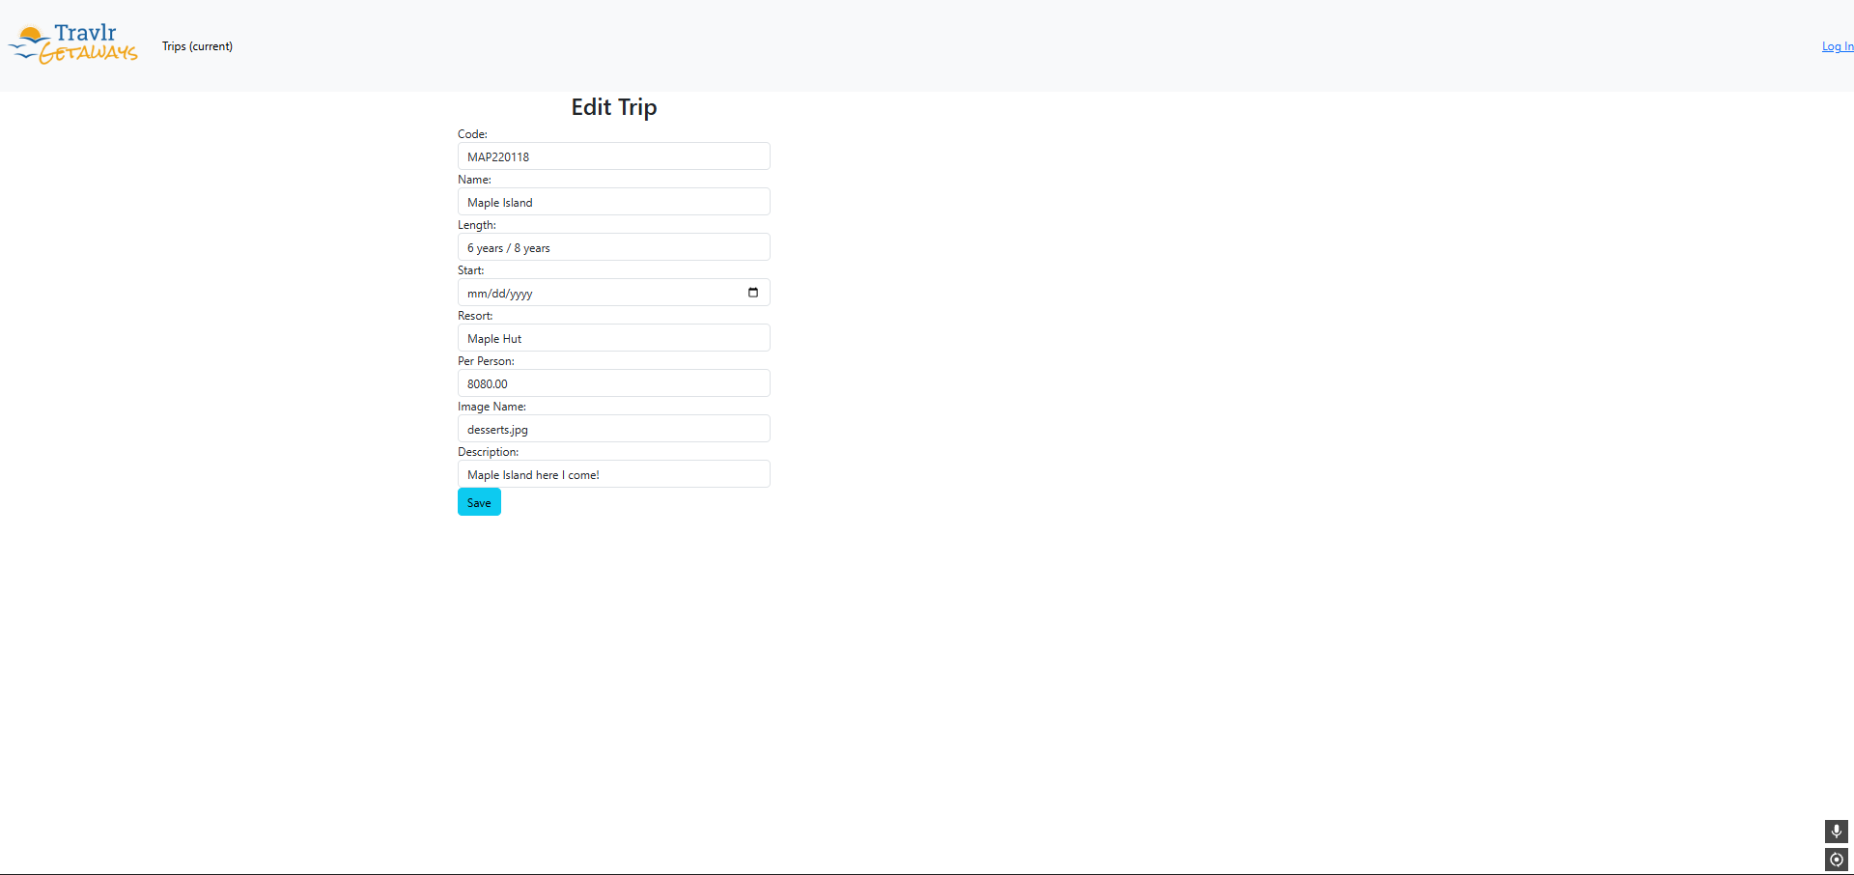

The Update screen (Switched Maple Island to Sweet Island):

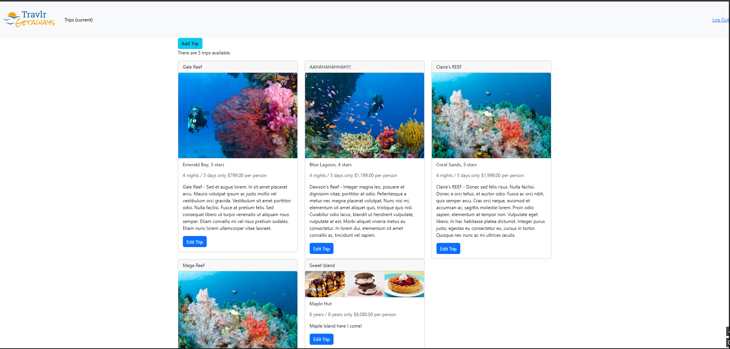

The Angular project is organized as a single page application in the app_admin folder. It uses components like trip-listing, trip-card, add-trip, edit-trip, login, and navbar to separate the user interface into reusable components. It also uses services like the trip data service and the authentication service, to make API calls and create the login. The structure is different from the Express project because Express handles more of the backend like routes, controllers, models, and views. Express would handles the backend API and customer facing pages while Angular handles the interactive frontend.
SPA helped provide a more detailed functionality to the project that a simple web application couldn’t. SPA allows updates to the page without the need to reload the whole page. The admin can see trips, log in, add/edit trips, and save updates through Angular. Angular moves the admin through different screens and the services would send requests to the Express API in the background. This ultimately makes the admin side more interactive than static html pages.
Testing was done by running the Express server, MongoDB, and the Angular admin application simultaneously. The GET functionality was tested by opening a Angular trip listing page and checking that trip data was gotten from MongoDB and display correctly in SPA. The edit feature tested GET for a singular trip by loading it in the edit form. The POST functionality was tested by logging in, adding a trip, and then making sure that trip was added in the Angular trip listing. The PUT functionality was tested by changing trip info in the edit form, pressing save, and making sure the existing trip was updated with the new info in MongoDB and the Angular trips. This made sure SPA was working well with the API to retrieve and update data.

